History (from Greek historia, meaning "\_\_1\_\_\_\_; [knowledge](https://en.wikipedia.org/wiki/Knowledge) acquired by investigation") is the study of the past. Events occurring before the invention of writing systems are considered \_\_\_2\_\_\_ History" is an [umbrella term](https://en.wikipedia.org/wiki/Umbrella_term) that relates to past events as well as the memory, discovery, collection, organization, presentation, and interpretation of information about these events. [Historians](https://en.wikipedia.org/wiki/Historian) place the past in context using [historical sources](https://en.wikipedia.org/wiki/Historical_source) such as \_\_\_\_\_3\_\_\_\_ documents and oral account. History also includes the [academic discipline](https://en.wikipedia.org/wiki/Discipline_(academia)) which uses [narrative](https://en.wikipedia.org/wiki/Narrative) to describe, examine, question, and analyse a sequence of \_\_\_4\_\_ events. The father of history is known as \_\_\_5\_\_\_\_a Greek historian, who lived in the 5th century B.C. History embraces all aspects of human lives. There are different types of history. Some of the are as follows:

Political 
History 
Diplomatic 
History 
Intellectual History 
Cultural 
History 
Social 
History 
no 880 
Economic 
History 

\_\_\_6\_\_\_history is about the human (historians) actions and how they developed history.

\_\_\_7\_\_\_\_ history deals with the analysis of political leaders, ideas, events, movements, activities and so on, along with the making of government policies (constitutions etc).

\_\_\_8\_\_\_\_history is the branch of history that focuses on the study of international relations between nations (between states).

History promotes patriotism and enhances responsible \_\_\_\_9\_\_\_\_citizenship. History equips us with vital skills: Skills that can be acquired from the study of history include \_\_10\_\_\_ analysis, research expertise and evaluation skills. These skills can be applied in other fields other than history itself. History is fun: Many people like to explore activities that occurred in the past and to\_\_\_11\_\_\_new things.

Studying history gives you an opportunity to explore activities that occurred. History is a good subject for \_\_\_12\_\_\_ and professional development. History helps us to find \_\_\_\_13\_\_\_. We can draw inspiration from such people and imitate their strength in solving the challenges that face us today. \_\_14\_\_ consciousness and cross-cultural appreciation can be realized through the study of historical events. Sometimes people behave in certain ways and we quickly rush to judge them without understanding why they are that way. When we study history, we come across many societies that have different cultures and norms and you may want to learn those cultures. It provides information about genealogy: It is a common practice to find people studying their \_\_\_15\_\_\_ history. This important because you get to know your family tree which in turn helps you avoid taboos such as marrying from your clan. People also like to identify with their forefathers and mothers especially if they were reputable concerning wealth, royalty and so on

A story is an \_\_\_16\_\_\_\_account of an event or sequence of events. A story can be a fiction, based on imagination or a non-fiction, based on \_\_17\_\_\_\_. Stories teach \_\_18\_\_ and serve as entertainment to listeners and readers

Differences between History and storytelling.

|  |  |
| --- | --- |
| HISTORY | STORYTELLING |
| History is objective | Storytelling can be \_\_\_19\_\_\_ |

History and storytelling have elements of myths, legend and \_\_20\_\_\_

History and storytelling are concerned with heroes and \_\_21\_\_\_

Sources of history are the working materials a historian uses in writing about the past. These materials are in different forms. They could be oral or written sources.

Oral sources are information passed through the words of \_\_22\_\_\_\_\_

Written sources are simply documentary sources or information

Anything that conveys information on a historical subject qualifies as a source in the study of history. Sources of history are also known as historical sources

Historical sources are classified into three categories. These are:

\_\_\_23\_\_\_sources: They are aggregates of primary and secondary sources

\_\_\_24\_\_\_sources: They are original pieces of information

\_\_\_25\_\_\_sources: They are documentary sources

They help historians to debunk erroneous views about \_\_26\_\_. Such as European and Arabic views about the African past

There are different types of primary sources of history. These are Oral sources, \_\_\_27\_\_\_\_\_and Archival materials

Oral sources are non-written sources. They are information passed through the words of mouth. They are also called oral history. They are used to obtain information in non-literate societies. There are two main types of oral sources, namely oral \_\_28\_\_\_ and oral evidence

(For question 29 - 32 Myth / Song / Folklores / Legend)

\_\_\_29\_\_\_ are traditional stories that may be true and untrue about the early history of the people and their societies.

\_\_\_30\_\_\_ are stories which have some factual bases about certain persons, such the Oduduwa about the origin of the Yoruba dynasty .

\_\_\_31\_\_\_\_\_ are traditional stories about the beliefs , culture , customs and traditions of a particular group of people

A \_\_\_32\_\_\_is a musical piece, or the sounds of some animals such as birds.

Oral evidence is an eye-witness account. It deals with events that are recent or contemporary, such as the annulment of June \_\_33\_\_\_ general elections of 1993 of Chief MKO Abiola.

Artefacts are tools or material remains of the past. The material remains are generated by archaeologists through \_\_\_\_34\_\_\_\_. The material remains are tangible objects.

Prominent sites in Nigeria, where archaeologists have carried out excavations, are Nok in \_\_\_35\_\_\_\_ State . Daima in Borno State , lle-Ife in \_\_\_36\_\_\_ State , and Igbo-Ukwu in \_\_\_\_37\_\_\_ State

There are two types of artefacts, namely relics and \_\_\_\_38\_\_\_\_\_

Relics: These are objects obtained through the digging of the earth crust, such as iron tools, stone objects , skeletons , wooden objects , bone tools and utensils

Monuments: These are immovable things, such as temples, shrines ancient cathedrals , tombs , and dwellings.

Taiwo Olowo's monument, Lago_ 
hotels.ng 
File:WELCOME TO LAGOS 17Jpg 
commons.wikimedia.org 
heritage sites and monuments 
thedailyreport_ng 
o' Haw rie 

The image above is an example of a \_\_\_39\_\_\_\_

Archives are places when historical documents are kept and preserved. Archives contain \_\_\_\_40\_\_\_\_(tertiary / primary / secondary) source documents about the activities of man in the society in the past. A person who works in archives is known as \_\_\_\_\_41\_\_\_\_ . Document in the archives are known as archival materials. Archival materials that you may keep on your laptop include family \_\_\_42\_\_\_\_

Secondary sources are documentary sources. A secondary source is also known as a \_\_\_\_42\_\_\_source.

Periodicals are publications published in series or periodically. They contain recent information on specific or topical issues. They are secondary sources of history. Periodicals are published daily, weekly, monthly and quarterly, an example is \_\_43\_\_\_that we receive every week at Heritage

A \_\_\_44\_\_\_\_ is an account of someone's life written by a person or persons.

An \_\_\_45\_\_\_ is an account of someone's life written by himself.

Historical sites are official locations or places of historical significance Historical sites are also known as Heritage sites. Historical site are maintained for members of the public to visit. Many historical sites offer guide tours for visitors. Example of historical sites are Olomo rock in \_\_46\_\_. Ogun State.

An Excursion in an educational field \_\_47\_\_\_, visit or journey to place of historical significance known as historical sites.

An exhibition is a public \_\_48\_\_\_\_of artworks, cultural and historical materials in an art gallery, a museum or at a trade fair.

A library is place where printed and non-printed materials are kept for easy access and usage. Printed materials are \_\_\_49\_\_\_, journals, monographs, conference processing, periodicals manuscripts, maps charts, and so on. The non –printed materials include computer, compact discs, (CDs) digitals video discs (DVDs), video tapes microfilms, and projects.

Cultural festivals are festival that have religions, cultural political and economic significance to the society. Most societies of the society. Most society of the world celebrate cultural festivals. Usually, they are celebrated \_\_50\_\_\_(daily / weekly / annually).

The Nok culture is the earliest \_\_51\_\_(gold / silver / Iron) Age culture in West Africa. It existed between the 5th and 2nd century BC and remains the \_\_52\_\_( youngest / oldest) cultures in Nigeria. Nok is a name of a small village in \_\_53\_\_\_\_State.

The figurine below are from \_\_\_54\_\_\_\_culture

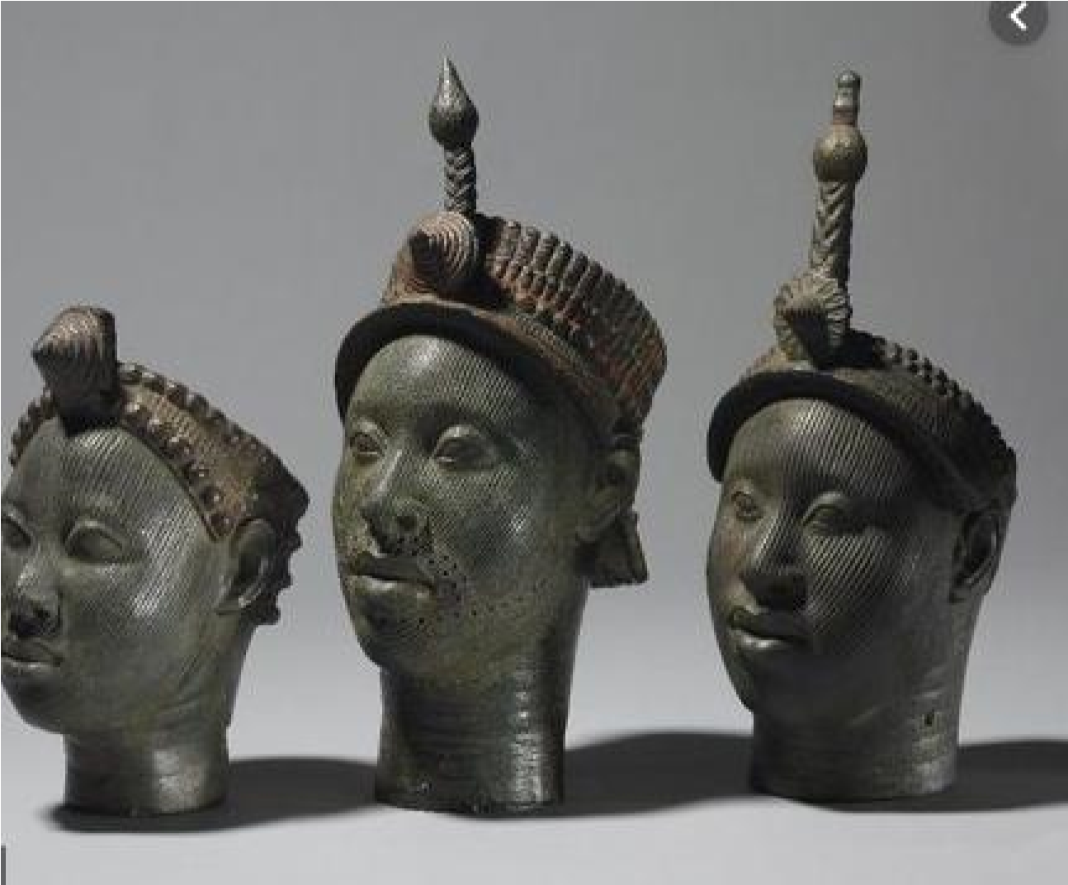

\_\_55\_\_\_ is regarded as the cradle of your civilization

The artwork below is from\_\_\_\_56\_\_\_Culture.

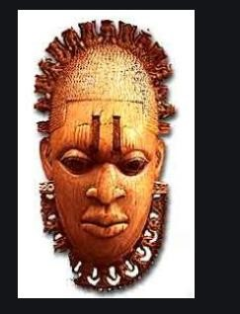

The \_\_57\_\_\_ culture is rich. Benin is at present located in Edo state of the south \_\_58\_\_ geopolitical zone of Nigeria. The First scientific excavation was carried by Graham \_\_\_59\_\_\_.

Igbo-Ukwu is located \_\_\_60\_\_\_ State of the south-east geographic zone in Nigeria. Thurstan \_\_61\_\_\_ , an archeologist, conducted archeological excavations at three sites at Igbo-Ukwu between 1959 and 1964 they are: Igbo \_\_62\_\_\_, Igbo Richard and Igbo Jonah

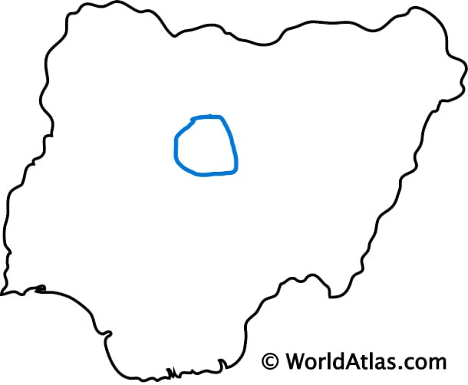

The area circled on the map is \_\_\_63\_\_\_(NOK / Igbo Ukwu / Ife / Benin) Culture